Evan Wilson

CST-235

August 25th, 2018

Instructor: Dr. Toure

Short Project 2

GitHub Repo: <https://github.com/ewilson87/CST235_ewilson>

For this assignment, I was/am confused some on the requirements so I ended up going with the only thing that I could figure out. The directions state to create a Java FX application that utilized the JavaBean from week one. I utilized a FXML format, creating the client application UI using Gluon Scene Builder. From within the NetBeans generated Java FX controller I had to create local variables for the text fields and pointed them to the client application using @FXML annotations. When the user clicks the button on the client application, it instantiates a JavaBean object from week one, processes the text file and outputs the required stats from the file.

Screenshot of initial application launch.

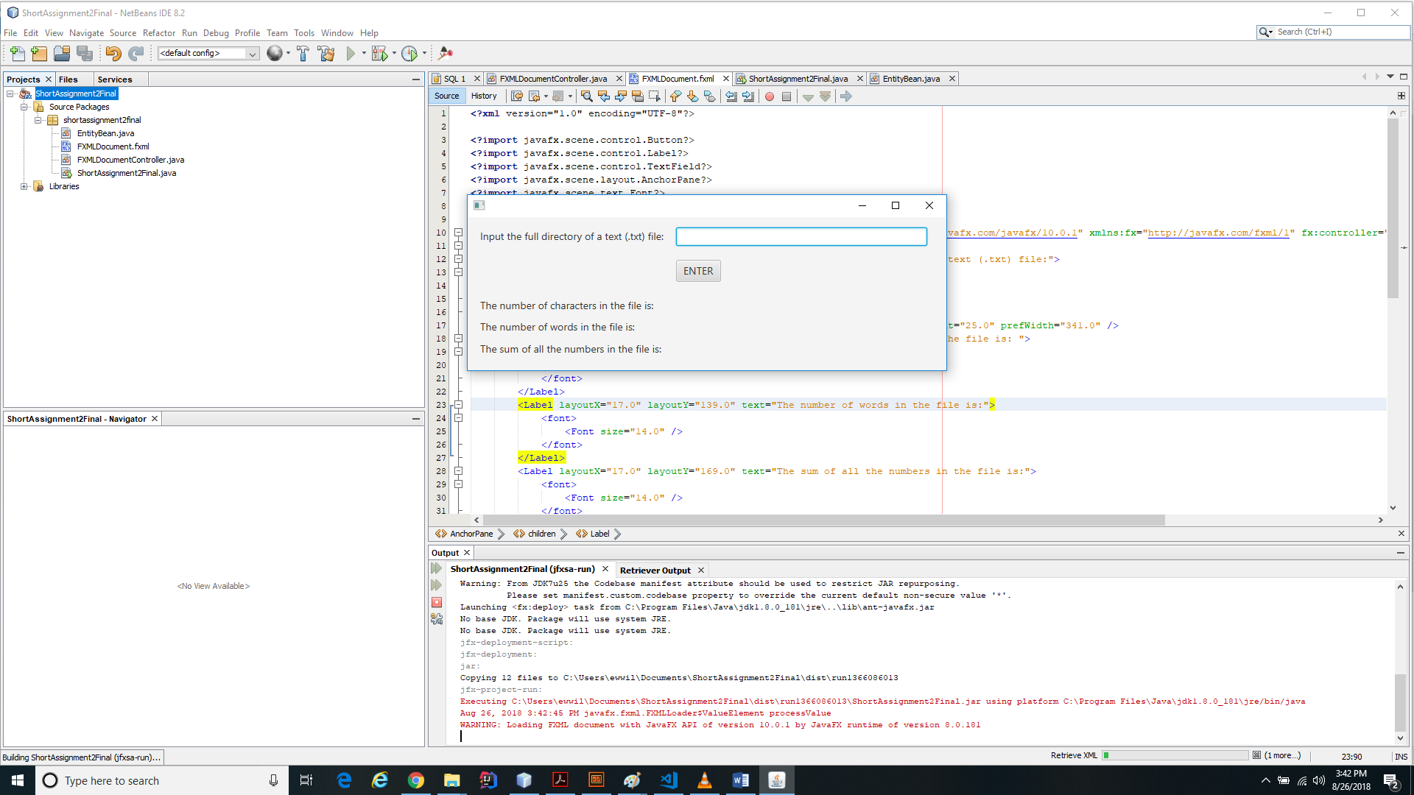

Screenshot showing details after processing an external text file.

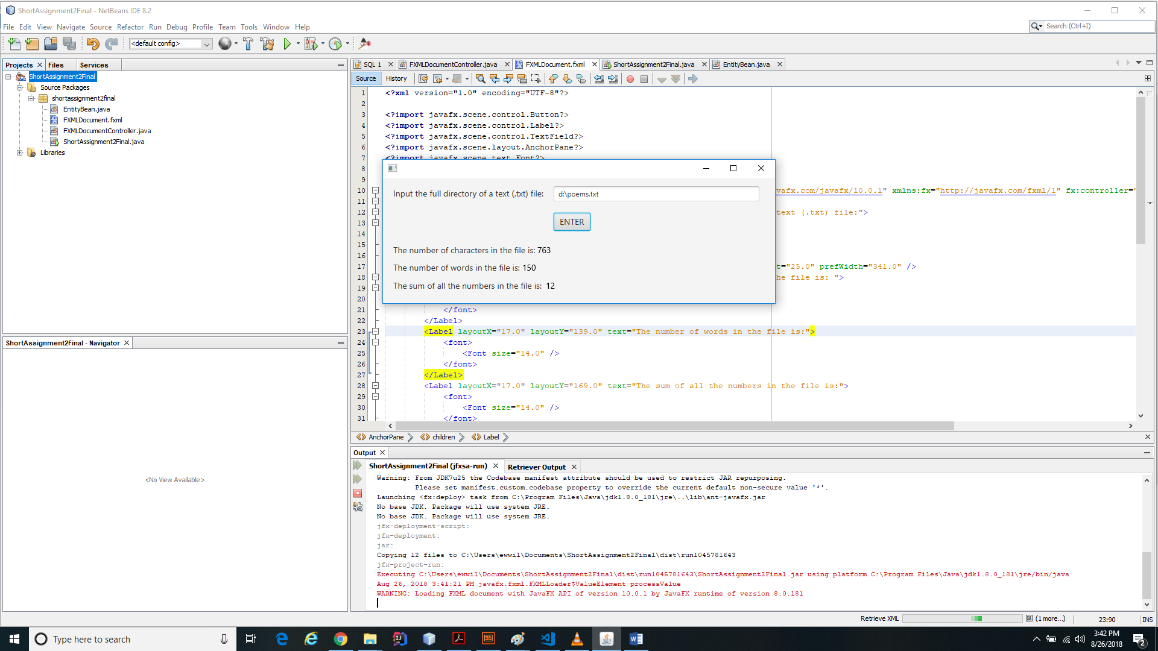

Screenshot showing error messages for incorrect file path or type

